**Ex:No: 9.1**

Date:

#### HIGH LEVEL PROGRAMMING EXTENSIONS (PROCEDURES)

##### Aim:

To implement procedures using program in MySQL.

##### PROCEDURES:

A procedure is a subprogram that performs a specific action.

##### Creating a procedure

We use the CREATE PROCEDURE statement to create a new stored procedure. We specify the name of stored procedure after the CREATE PROCEDURE statement. The DELIMITER command is used to change the

standard delimiter of MySQLcommands (i.e. ;). As the statements within the routines (functions, stored procedures or triggers) end with a semi-colon (;), to treat them as a compound statement we use DELIMITER.

Calling stored procedures(Executing a procedure)

In order to call a stored procedure, you use the following SQL command:

CALL stored_procedure_name();

##### Program 1:

Create a simple procedure to get all the records from the table ‘student_info’ which have the following data:

|  |  |  |  |  |
| --- | --- | --- | --- | --- |
| mysql> select * from student_info; | | | | |
| +- | + | + | + | + |
| | id | | Name | | Address | | Subject | | |
| +- | + | + | + | + |
| | 100 | Aarav | | | Delhi | | Computers | | |
| | 101 | YashPal | Amritsar | History | | | | | |
| | 105 | Gaurav | Jaipur | | | | Literature | |  |
| | 110 | Rahul | | | Chandigarh | History | | | |
| + - | + | + | + | + |

##### Program 2:

Create a stored procedure GetCustomerLevel() that accepts two parameters customer number and customer level.

First, it gets the credit limit from the customers table.

Then, based on the credit limit, it determines the customer level: PLATINUM , GOLD , an SILVER.

The parameter p_customerlevel stores the level of the customer and is used by the calling program.

The following flowchart demonstrates the logic of determining customer level.

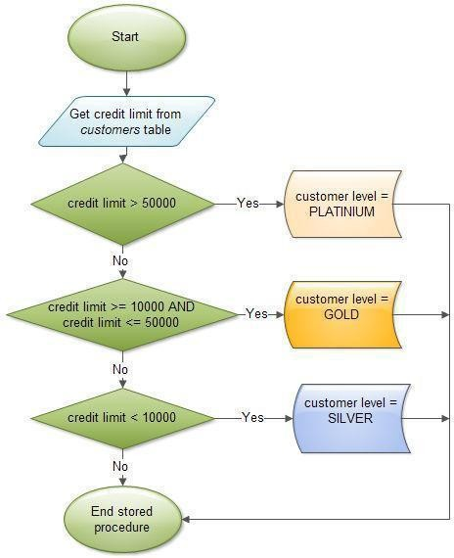

The table ‘customers’ should have the following attributes: customers(cno , cname, creditlimit)

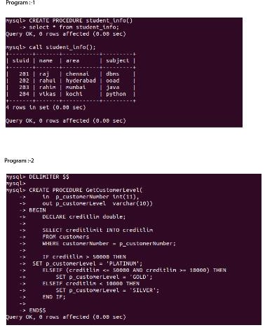

**RESULT:**Thus the program in MySQL executed successfully.

**Ex:No: 9.2**

Date:

**Aim:**

#### HIGH LEVEL PROGRAMMING EXTENSIONS (FUNCTIONS)

To implement Functions using program in MySQL.

##### FUNCTIONS:

A function is a subprogram that computes a value. Creating a function

The CREATE FUNCTION statement is also used in MySQL to support UDFs (user-defined functions). A UDF can be regarded as an external stored function.

##### MySQL stored function syntax

CREATE FUNCTION function_name(param1,param2,…)

RETURNS datatype [NOT] DETERMINISTIC

statements

##### Program 1:

Create a function that returns the level of a customer based on credit limit.(Use the IF statement to determine the credit limit).

The table ‘customers’ should have the following attributes: customers(cno , cname, creditlimit)

If credit limit > 50000 then customer_level = PLATINUM

If credit limit >= 10000 AND credit limit <= 50000 then customer_level = GOLD If credit limit credit limit < 10000 then customer_level = SILVER

RECURSION in Mysql Procedures

Mysql version should be >= 5.

Have to set system parameters. This means putting the recursion count limit. SET @@GLOBAL.max_sp_recursion_depth = 255;

SET @@session.max_sp_recursion_depth = 255;

##### Program 2

Write a recursive MySQL procedure compute the factorial of a number .

##### OUTPUT;

###### 1

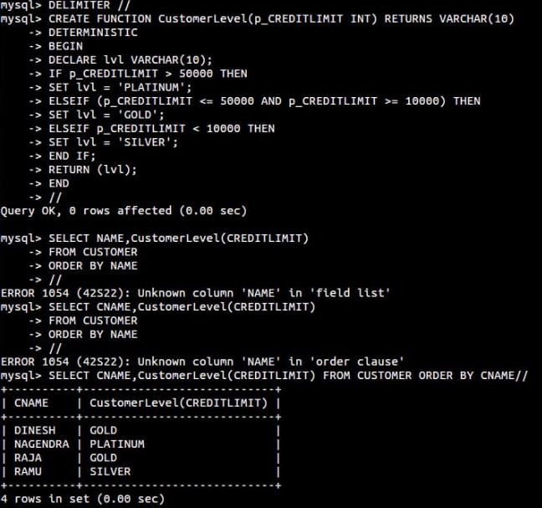

2)



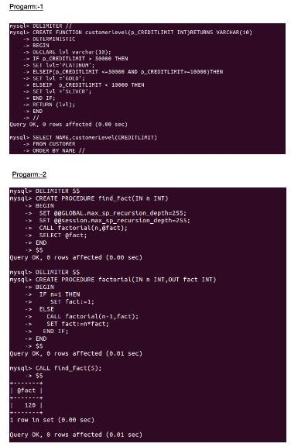

**RESULT:** Thus the Functions using program in MySQL executed successfully